[E128] Mash temperature switch

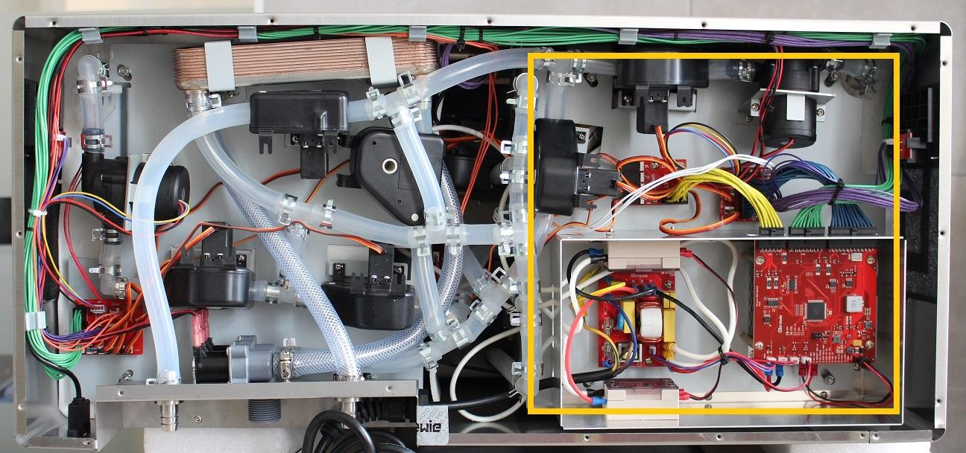

The mash temperature switch is located under the mash side service plate attached to the bottom of the mash tank.

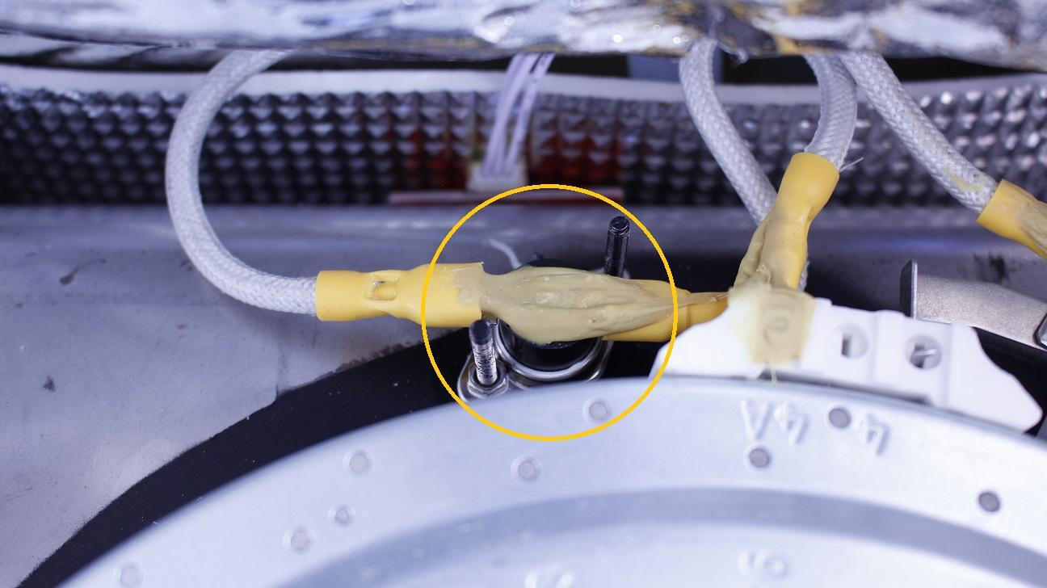

To reach the temperature sensor it is necessary to remove the whole plate:

1. Disconnect the silicone tube from the outlet of the mash tank by pulling off the clamp then the tube from the L fitting.
2. Disconnect the purple cable from button PCB.
3. Remove the cable bundle from the two marked holders.
4. Unscrew the marked 4 locknuts holding the mash plate.

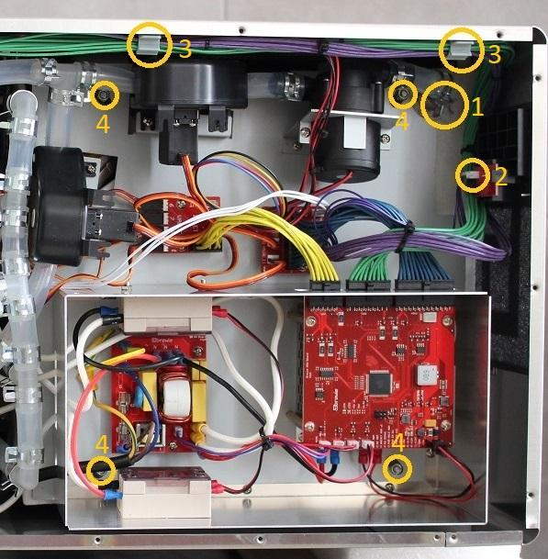

Open up the whole plate.

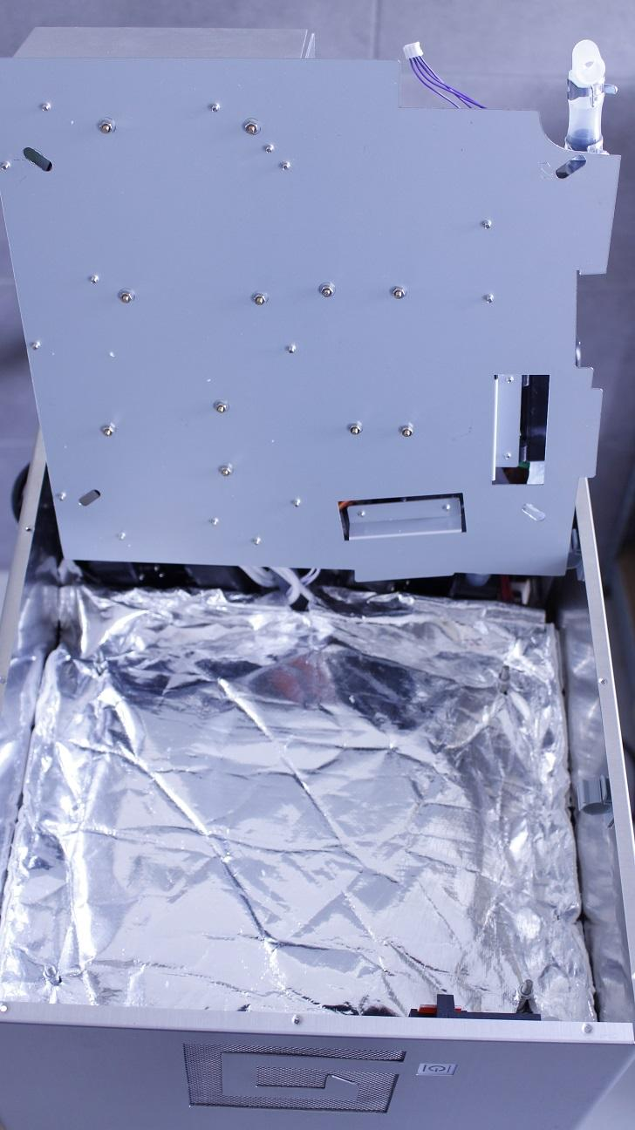

Carefully pull off the heat insulation from the threads and the outlet pipe.

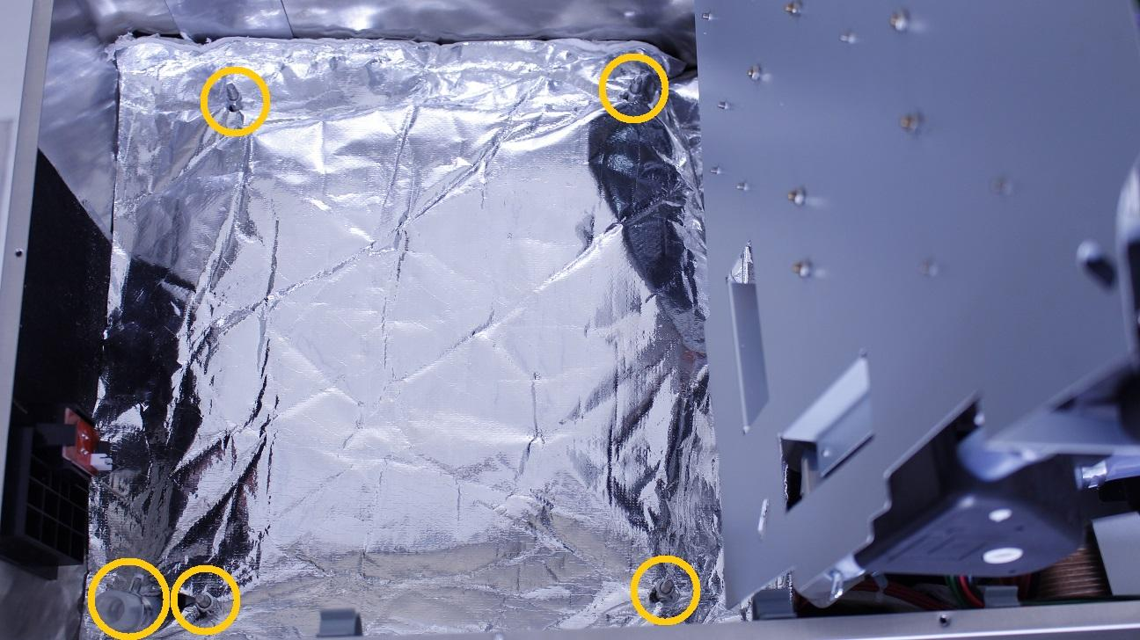

Simply turn the fastening clamps aside from the heater element and remove the isolation rubber.

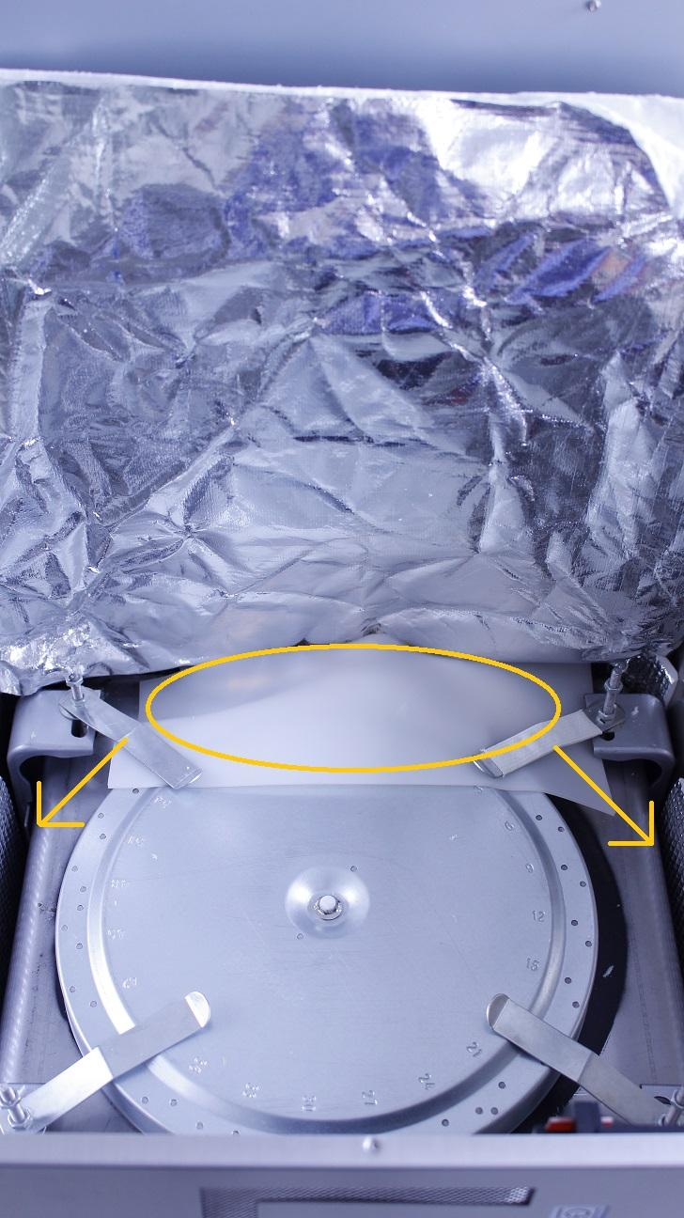

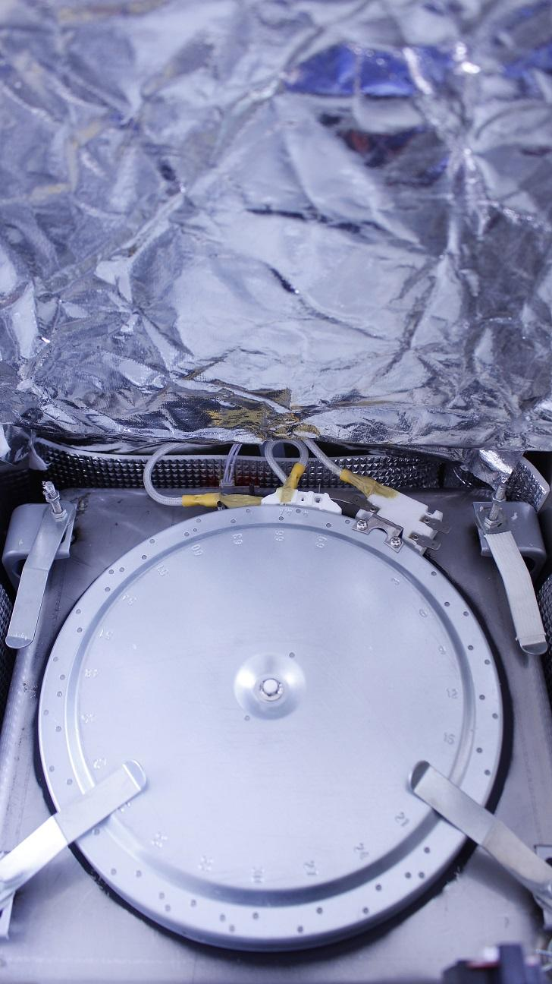

Unscrew the indicated locknuts holding the switch in place and cut the solidified adhesive to remove the cables from the pins.

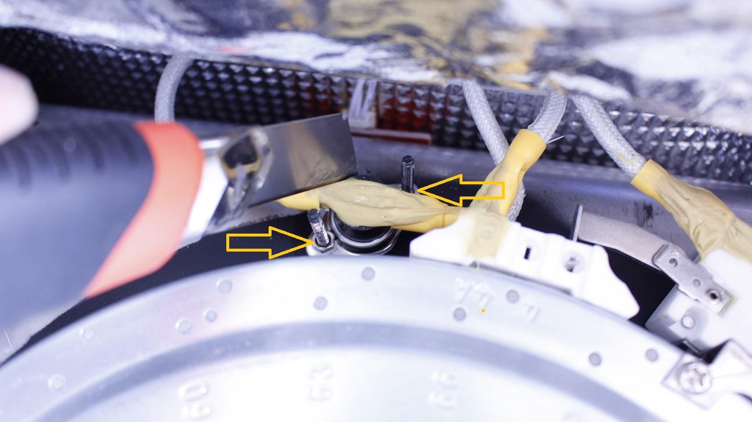

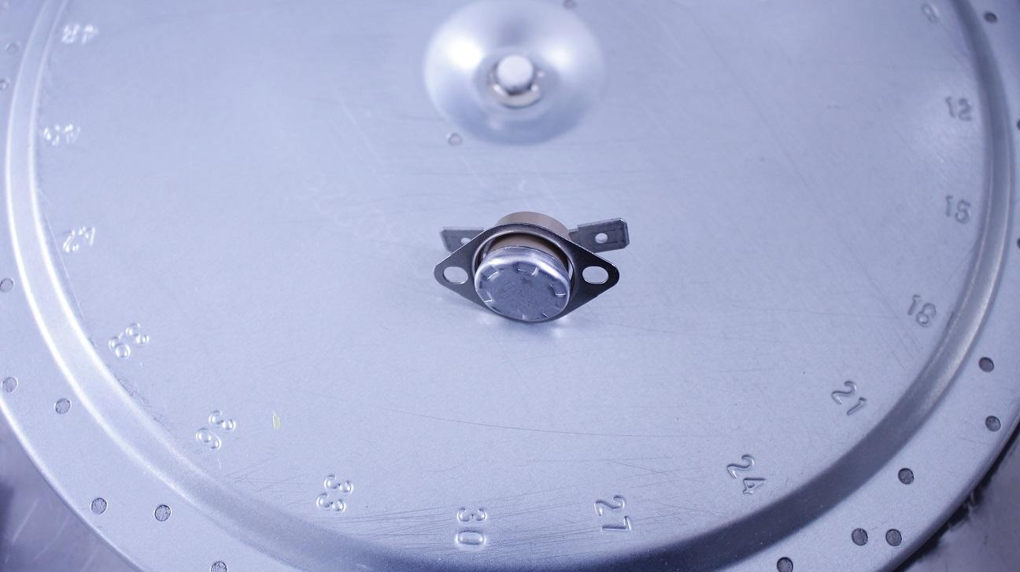

Reassemble consists of the same steps in reverse.